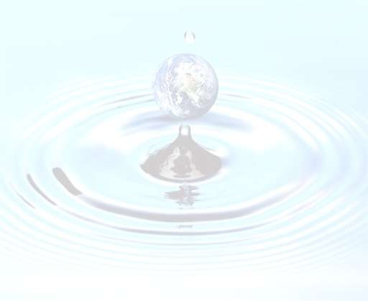


2024
Annual Water Report

Table of Contents
- INTRODUCTION 3
- WID WATER SYSTEMS 3
- WID WATER DISTRIBUTION SYSTEM 6
- SCADA SYSTEM 7
- WID WATER QUALITY CONTROL PROGRAM 8
- WATER CONSERVATION 8
- WATER QUALITY COMPLAINTS - FAQ 10
- ROUTINE MAINTENANCE PROGRAM 13

APPENDIX A – WELL & RESERVOIR LOCATION MAP 15
APPENDIX B – FULL SPECTRUM ANALYSIS 16

INTRODUCTION
The Wynndel Irrigation District is the purveyor of potable drinking water to users connected to the Wynndel and Creston Dyking District community water system. This report is provided in fulfillment of the WID’s obligations under the Provincial Drinking Water Act and associated regulations, as well as the terms and conditions of the WID Water System Operating Permit. Enforcement of the regulations and issuance of water system permits are the responsibility of the Interior Health Authority.

WYNNDEL IRRIGATION DISTRICT WATER SYSTEMS
The WID has 2 separate water sources available to provide drinking water to the community.

The primary supply of potable water is delivered from the Duck Creek Water Treatment Plant that is operated by the WID. The water system derives source water from Duck Creek, which is classified as a Community Watershed, supplying water to both Wynndel and Creston Diking District. Historic water quality data for Duck Creek indicates that, in general, the water quality falls within acceptable levels for the majority of parameters in the Canadian Drinking Water Quality Guidelines. Coliform levels, however, typically exceed the criteria and exhibit high seasonal variability
Water from Duck Creek accounts for over 99% of the current potable water supply for the WID. The treated water is monitored for free chlorine residual as it enters the main reservoir, and an automated chlorination dosing system compensates for any low chlorine residual that may be present, ensuring safe disinfection for WID consumers.

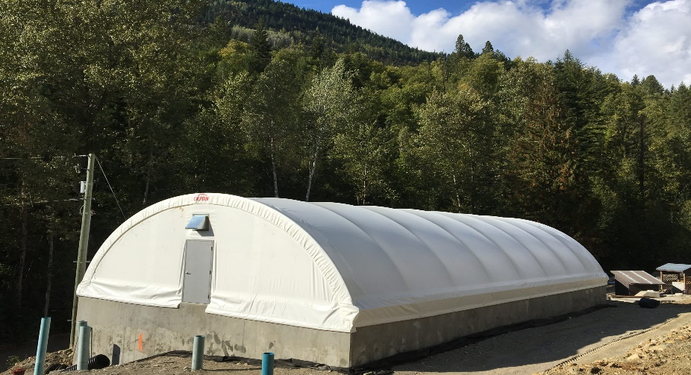

Duck Creek Water Treatment

WID WATER DISTRIBUTION SYSTEM
Duck Creek can independently supply enough water for the water supply demand even during peak consumption in the summer months. Chlorine is added to the reservoir circulation line to ensure adequate disinfection of any possible contamination as the water is transported through the distribution grid to consumers’ homes.

Many kilometers of water main interconnect the reservoir to the community. 323 residential connections, 2 industrial and 1 commercial connection ensure that the community have unrestricted access to the WID water supply.

SCADA SYSTEM
Critical elements of the water distribution system are monitored by in-line instrumentation that reports information back to a Supervisory Control and Data Acquisition (SCADA). A SCADA is a computer system that is used for gathering and analyzing real-time data. A SCADA system gathers information from control points, transferring the information back to a central site. It alerts the home station of any potential problems within the system, carrying out necessary analysis, and control and displays the information in a logical and organized fashion.

The WID SCADA monitors flow, reservoir levels, chlorine residual, and equipment status among other critical parameters. Should any problem develop, the SCADA analyzes the situation and informs the Operations staff of the fault(s) through email, so that developing problems can be dealt with by staff no matter what time of day.

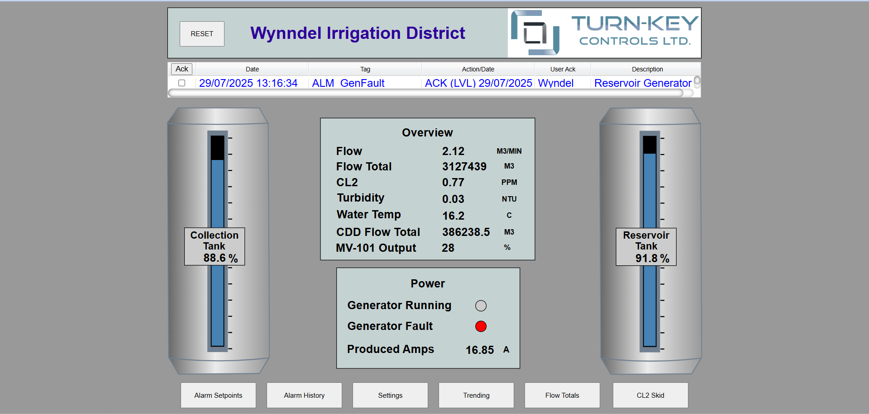

- PROTECTING THE COMMUNITY - WID WATER QUALITY CONTROL PROGRAM
WID water meets, or is better than, all federal and provincial health-related guidelines. WID’s water quality from potable water is tested annually at an independent accredited Laboratory for a full spectrum of basic water chemistry parameters. The full analyses of these results are posted on the WID website, www.wynndelirrigation.com, and are detailed in Appendix “B” of this report.
Additionally, the WID conducts bacteriological sampling on a weekly basis for Total Coliform and Escherichia Coli (E.Coli) from various locations throughout the water distribution system. The sampling frequency and number of samples are determined by the community population. The WID conducts 1 sample on a weekly basis from locations: Wynndel Foods, Creston Diking district inlet or the Wynndel Community Center on the water distribution system, which is representative of the distribution grid. Samples are sent to an independent accredited Laboratory for bacteriological analyses for Total and Fecal (E. Coli) Coliforms.

Should there be any indication of coliform presence in the samples, both the WID staff and Interior Health Authority are immediately notified, and procedures are put into effect to protect the community water supply as well as identify a possible source of contamination. Total Coliform testing is a bacterial indicator test for water and sanitary quality of foods. Coliforms can be found in the aquatic environment, in soil and on vegetation, and their presence is used to indicate that other pathogenic organisms of fecal origin may be present.

Of all the samples sent out for analyses in 2024, there was never a presence of E.Coli reported in the potable water supply.

Protecting our watersheds

The WID has an obligation to provide safe drinking water to the community. Even though the WID has many water quality control measures in place to ensure an innocuous water supply, the public can also contribute to protection of our water sources by:
- Proper disposal of chemicals;
- Minimizing the use of fertilizers and pesticides;
- Disposal of unused or out-of-date pharmaceuticals at your local pharmacy;
- Using recreation areas responsibly;
- Picking up after your pet; and,
- Using water wisely - conserving where you can.

WATER CONSERVATION
Since 2022, approximately when the Duck Creek Water Treatment Facility SCADA was commissioned, detailed daily water records and measurements for the Wynndel community have been tabulated. Additionally, water consumption for the Creston Diking District, WID single largest commercial point demand has been kept. This data aids the WID in projecting future potable water demands in correlation with expected population growth and water usage trends.


In the WID, where we are surrounded by an abundance of water, it is easy to forget that water is a precious and limited resource. During the summer months, water consumption increases by as much as 50%, and during hot dry spells, water can be used up faster than the Duck Creek Water Treatment Facility can replenish the demand.

Water conservation is the practice of permanently reducing domestic water consumption. Domestic water consumption can be divided into two major categories – inside water use and outdoor water use.

Reductions in outdoor water use have an impact all year round and help to reduce the Average Daily Demand. An additional benefit is a similar reduction in domestic wastewater flow. The WID currently implements water conservation measures such as the following:
- Voluntary water restrictions go into effect automatically between June 1st and September 30th each year.
- Watering in the early morning and late evening to reduce evaporation losses.
- Planting native or drought resistant plant species.
- Maintaining and adjusting underground irrigation systems to eliminate overspray.

Residents can do their part by demonstrating indoor water conservation measures in their own homes by:
- Taking short showers instead of baths.
- Not running water continuously when preparing food, washing dishes by hand, shaving, or brushing teeth.
- Fixing leaky toilets and faucets.
- Using dishwashers and clothes washers only when full.
- Installation of ultra low flow toilets and showerheads. Installation of faucet aerators.

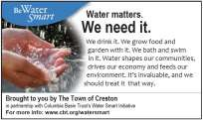

Water conservation can benefit a variety of issues and players in the community:
- Environment and Wildlife:
  - Reduces extraction from surface and groundwater sources.
- Operations:
  - Reductions in outdoor water use, typically lawn irrigation, help to reduce the Maximum Day and Peak Hour Demands during the summer months.
  - Reduced electrical and disinfection costs.
- Finances:
  - Potential for minor reduction in system size and lowered costs.
  - Reduced peak demands have the potential of deferring infrastructure costs.

- WATER QUALITY COMPLAINTS - FREQUENTLY ASKED QUESTIONS
Infrequently, the WID receives water quality complaints, or general questions about the water supply.

What is Fluoride?

Fluorides are chemical compounds, naturally found in air, water, soil, and almost all foods. Fluorides are commonly released into the environment by erosion resulting in natural concentrations in surface and ground waters.

Most Canadians are exposed to fluorides on a daily basis, both through trace amounts found in foods and those that are added to some drinking water supplies to prevent tooth decay.

WID does not add fluoride to content to its treated water.

What is water hardness?

Water hardness is caused by calcium and magnesium in the ground and surface water. If either of these minerals are present in your drinking water in high concentrations, the water is considered hard. These minerals come from rock such as limestone that dissolves in our river system. The result of hard water is difficulty making lather or suds for washing and a build-up of minerals on taps and other fixtures.

Water containing low concentrations of calcium or magnesium is called soft water. Municipalities with soft drinking water often have higher incidences of water pipe corrosion (low pH). The degree of hardness in drinking water is commonly classified in terms of its concentration of calcium carbonate:

Hardness Rating | Concentration of Calcium Carbonate (mg/L ) | Concentration of Calcium Carbonate  (grains/imperial gallon)
Soft | 0 to <75 | 0 to <5.2
Medium Hard | 75 to <150 | 5.2 to <10.5
Hard | 150 to <300 | 10.5 to <21
Very Hard | 300 and greater | 21 and greater

Are there health issues with water hardness?

There is no known health effects associated with calcium and magnesium minerals in drinking water. However, conventional water softening systems (those that use salts) may not be suitable for people on sodium-reduced diets.
We recommend that consumers thoroughly research the various water softener systems available before deciding whether or not to soften their water. Also, water softeners should be connected so that the water you are drinking is not softened.

How hard is WID water?

The September 2024, Wynndel Drinking Water Analysis reporting for the Duck Creek Reservoir recorded an average Calcium Carbonate measurement of 100.0 mg/L.
Based on that information, consultation with the chart above shows that the WID water supply has medium hard water, so there is no requirement for consumers to install or use water-softening equipment but more up to the consumer on their preference.

Why is Chlorine added to the Water Supply?

One of the most asked questions from consumers is about the level of chlorine in the water and why we put chlorine in the water in the first place.

We like to think our water is perfectly safe to drink. In our minds we imagine our water has been thoroughly sterilized and is 100% pure. What we do not always understand though is that our water is simply disinfected. In other words, a chemical is used to kill most germs.

Chlorine kills bacteria on contact but also leaves a residual in the water to keep the water disinfected until it reaches your faucet. Water leaves the Duck Creek Water Treatment Facility sterile, but it still must travel through kilometers of pipe and reservoirs in order to make it to your home. All the time the water is traveling to you there is a potential for contaminants to be introduced. Thus, the chlorine is still in the water to prevent any germs from making their way into the water system.

Chlorine residuals in Wynndel are closely monitored on a real time basis at the Reservoir, which feeds the WID’s water distribution grid.
Incoming chlorine residual from the Duck Creek water supply is monitored by an in-line analyzer, and re-chlorination is automatically administered if the incoming residual drops below a pre-set set point. As chlorine loses its disinfectant qualities through time and chemical reaction with microorganisms, the level of chlorine residual will change. Dependent on location within the water distribution grid, the chlorine residual will differ. The further from the reservoir, the lower the chlorine residual can be expected.
In order to protect consumers at the furthest distance from the reservoirs, the reservoir chlorine concentration is kept high enough to allow for a minimum free chlorine residual of 0.2 mg/L at the furthest points along the distribution grid. To achieve this, the Reservoir free chlorine residual is maintained at approximately
0.7 mg/L.

Alternatives to Chlorine

Eliminating water pollution and cleaning up our watersheds are not going to happen overnight, but alternatives to chlorination for water treatment do exist. Several European and Canadian cities now disinfect their water supplies with ozone instead of chlorine. Currently, a handful of U.S. cities do the same, most notably Las Vegas, Nevada and Santa Clara, California.

There are many articles on the internet that explain the necessity for disinfection of potable water supplies and the various options that are available to consumers who prefer to remove chlorine in their water. There are many products on the market that remove chlorine residuals at the tap and are easily installed and reasonably priced.

For those of us who do not have the luxury of ozonized tap water, we do have other options. There are many websites, such as the consumer information website, WaterFilterRankings.com, that compare various water filters on the basis of price and effectiveness. The site reports that filters from Paragon, Aquasana, Kenmore, GE, and Seagul remove most, if not all, of the chlorine, THMs and other potential contaminates in tap water. Prices vary accordingly as to what particular filtration systems can strip from the water, but if all you want is to remove the incoming chlorine residual from your water supply, an activated carbon filter is recommended. Unit pricing can be under $100 for an activated carbon filtration unit, although when researching various filtration units, it is important to take into consideration the availability and replacement cost of filters.

Concerned consumers without the money to spend on home filtration, though, can just rely on good old-fashioned patience. Chlorine and related compounds will make their way out of tap water if the container is simply left uncovered in the refrigerator for 24 hours.

Why is my water yellow or rusty color?

Water main repairs, construction and other maintenance work in your area can cause some rust and sediment, which normally adhere to the inside of the water main, to break away. Fire hydrant flushing can also cause this inconvenience. The discolored water is safe to drink but may cause water to appear dirty. If this condition occurs in your system, allow the cold water tap to run for five to ten minutes to flush your pipes. If the condition persists, contact the WID at 250-866-5312.

Why does my water have a milky or cloudy appearance?

Air bubbles in the water may cause a milky or cloudy appearance. This is especially true in cold water. These bubbles pose no health risk. Cloudiness appears more often in the winter when the water is cold. If the water is allowed to sit, the air will dissipate, and the water will clear.
Additionally, the use of faucet aerators creates elevated levels of dissolved oxygen in the water, and warm or hot water will also create the effect of milky or cloudy water.

My water smells musty at one faucet?

If the musty odor occurs only at one faucet, the odor is related to something at or near the faucet. Try cleaning the drain, this often removes the odors.

Why does my water taste stale?
Drinking water may taste stale if faucets that have not been used in a while. Run the water briefly to allow fresh water from the water main in the street into your plumbing. If you have any concerns about the quality of your water, please contact the WID.

ROUTINE MAINTENANCE PROGRAM

Distribution System
- Water mains are flushed using a uni-directional flushing program.
- Air relief valves are cleaned.
- Fire hydrants are completely disassembled and inspected on a 2-year rotation.
- Painting and brush out around hydrants is performed as needed.

Reservoirs
- Daily security check of tanks and compounds.
- Daily checks of pump flows, chlorine, and turbidity levels.

APPENDIX “A” - DISTRIBUTION MAP

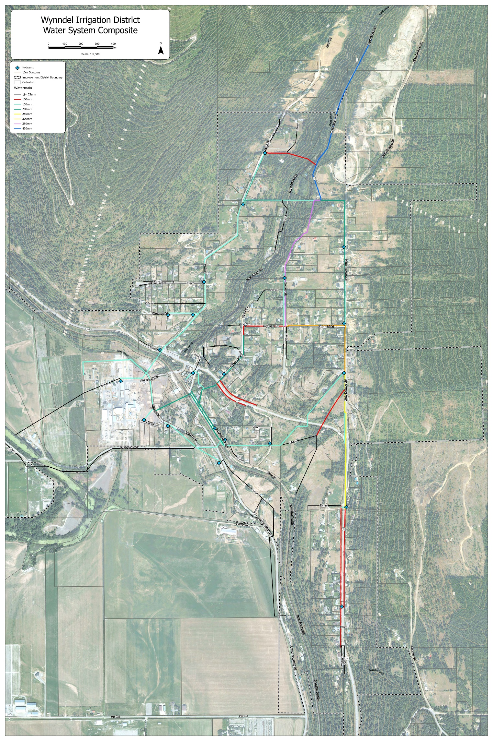

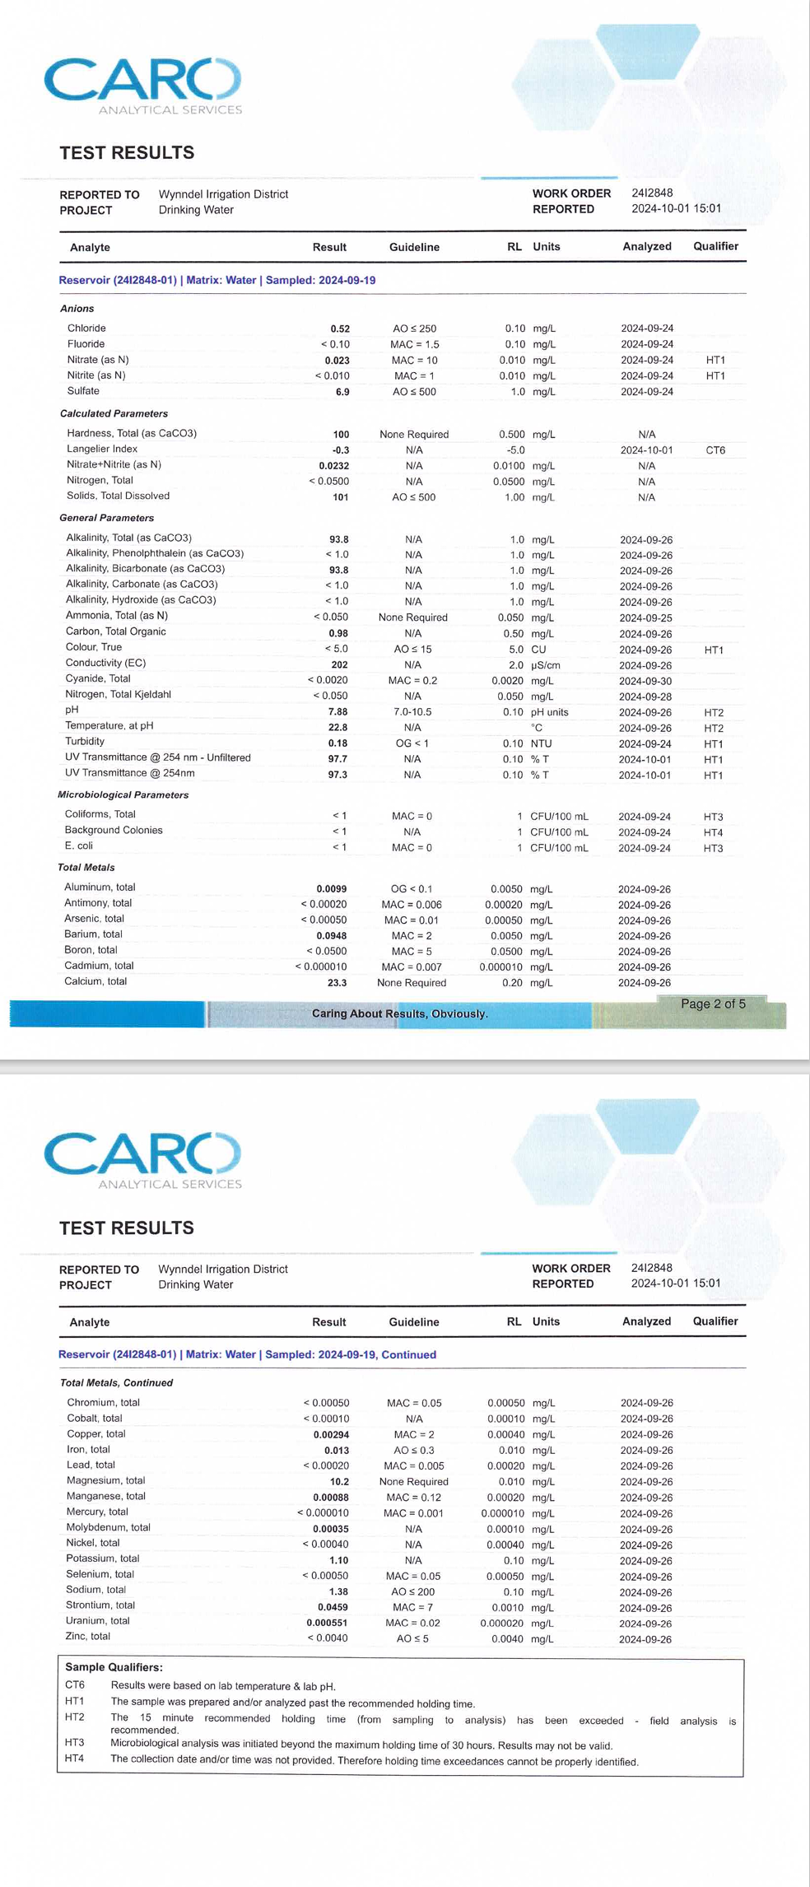

APPENDICE
mg/L | = | milligrams per liter (parts per million)
NTU | = | Nephelometric Turbidity Units, a measure of water clarity
AO | = | Aesthetic Objective
µg | = | microgram (one part per billion)
MAC | = | Maximum Acceptable Concentration
MPN | = | Most Probable Number
OG | = | Operational Guideline (treated water)
< | = | “less than”
≤ | = | “less than or equal to”

Microbiological Organisms (<1 means not detected)

Water Quality Parameter | Units | Canadian Drinking Water Guidelines |  |  | Major Source
Water Quality Parameter | Units | Crawford Hill Reservoir | Well # 2 | Well # 3 | Major Source
E.coli | MPN/100 mL | <1 | <1 | <1 | Domestic animals, wildlife and human waste
Total Coliform | /100 mL | <1 | <1 | <1 | Soil, domestic animals and wildlife

* Bacteriological testing for E. Coli and Total Coliforms are conducted weekly from locations throughout the water distribution system, including the Creston Diking District and Wynndel Community Center and Wynndel Foods. All bacteriological samples taken during 2024 were analyzed as negative for both E.Coli and Total Colif

